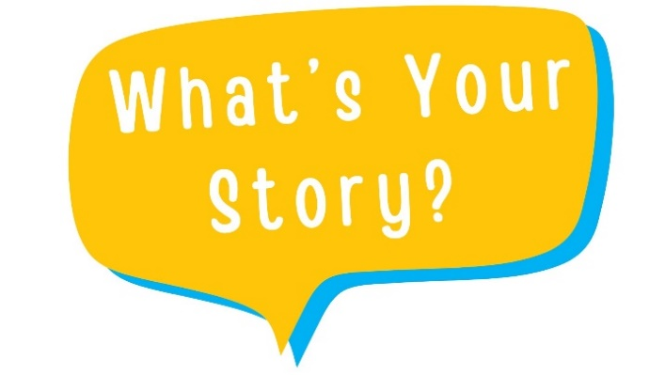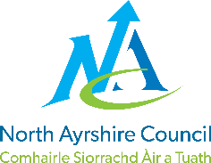

Consent to share work created for What’s Your Story?

Thank you for taking part in What’s Your Story? We hope you enjoyed the experience.

Your story will reflect how our lives have changed, tell future generations how we survived a global pandemic and take a moment to remember those that we lost and celebrate our communities and local environment.

Please complete this form to consent to your audio story being shared on North Ayrshire Libraries’ websites and social media.

We will never edit or change your story without asking your permission first.
You can ask us to stop sharing your piece at any time by emailing librarysupport@north-ayrshire.gov.uk. If you choose to stop sharing your piece on North Ayrshire websites and social media, we will no longer keep a record of your contact details from this project.

You can ask to see the details we hold for you at any time by emailing librarysupport@north-ayrshire.gov.uk. We want to make sure that your personal information is accurate and up to date. You may ask us to correct or remove information you think is inaccurate.

Please tick each of the boxes which you agree to below. You do not have to tick every box.
□ I agree for my audio story to be shared on North Ayrshire Libraries’ websites, e.g. You Tube Channel.
□ I am happy for my audio story to be shared on North Ayrshire Libraries’ social media e.g., as an embedded video or as a link on North Ayrshire Libraries’ Facebook page.
□ I am happy to be contacted later about sharing my audio story at a North Ayrshire Libraries’ event

I wish that my recording is anonymised: Yes □ No □
□ If you ticked yes to the above, please tick here if you are happy for your story to be recorded by a voice actor.

I consent to my name being used in my audio story: Yes □ No □

If you ticked any of the boxes above, please tick the next box and provide your contact details below.

□ I understand that I can ask North Ayrshire Libraries to remove my audio story from their websites/social media at any time by emailing librarysupport@north-ayrshire.gov.uk

Participant
Name
Telephone
Email
Audio Story Title
Signed
Date

What’s Your Story? Development Officer
Name | William Poulter
Signed
Date

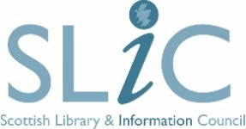This Project is supported by the Scottish Government Public Library Improvement Fund

