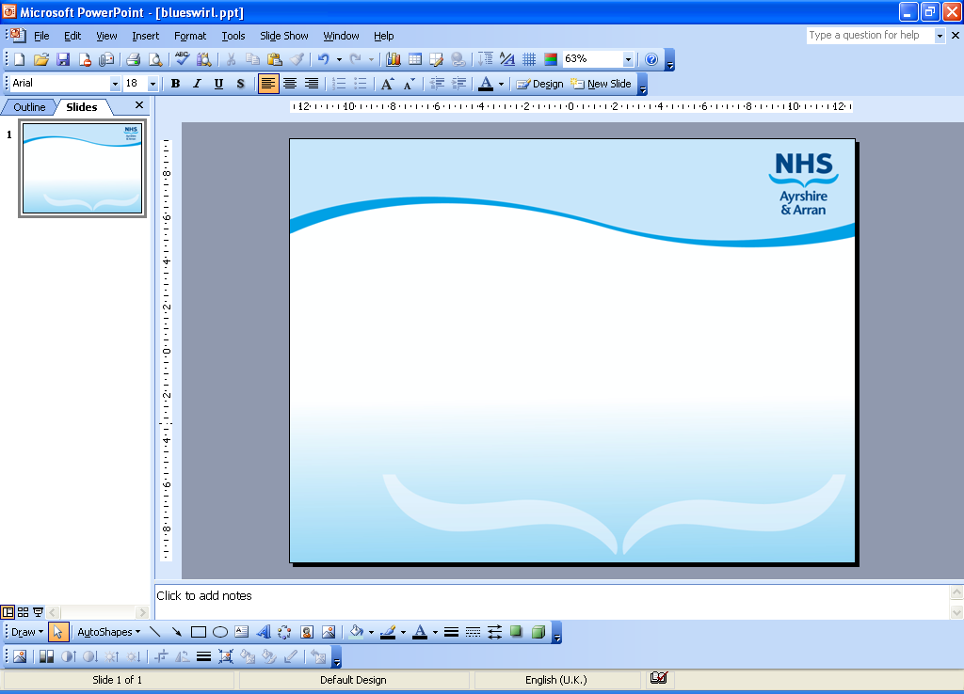

Title: | G XXX
Document Status: | Developing
Document Type:
Version Number:
Document location:
Author:
Owner:
Approved By:
Date Effective From:
Review Frequency:
Next Review Date:

Revision History:
Version: | Date: | Summary of Changes: | Responsible Officer:

Approvals: this document was formally approved by:
Name & Title / Group: | Date: | Version:

Dissemination Arrangements:
Intended audience: | Method: | Date: | Version:

Linked Documentation:
Document Title: | Document File Path:

NB. This document is uncontrolled when printed. The contents of this document are subject to change, any paper copy is only valid on the day of printing. To ensure you have the most up to date version of this document, please use the link to access the document directly from AthenA or contact the Author.

Contents
1.0 Introduction 3
2.0 Aim of Guideline – what do you want to achieve with this guidance? 3
3.0 Scope of Guideline – who is this guidance aimed at ? 3
4.0 Guideline Framework 3
5.0 Equality and diversity impact assessment 3
6.0 Related NHS Ayrshire & Arran Documents 3
7.0 References / Bibliography 3
8.0 Appendices 3

1.0 Introduction

2.0 Aim of Guideline – what do you want to achieve with this guidance?

3.0 Scope of Guideline – who is this guidance aimed at ?

4.0 Guideline Framework
Text /Flowchart or both

5.0 Equality and diversity impact assessment
The impact on the protected characteristics has been fully considered using an Assessment for Relevance Form and is open to scrutiny by service users/external partners/Equality and Human Rights Commission - Ask Marie for this form

6.0 Related NHS Ayrshire & Arran Documents

7.0 References / Bibliography

8.0 Appendices

